**Industrial Internship Report on**

**”** **Smart City Traffic Forecasting &**

**Mining Process Quality Prediction”**

**Prepared by**

**Sneha D V**

|  |
| --- |
| *Executive Summary* |
| This report provides details of the Industrial Internship provided by upskill Campus and The IoT Academy in collaboration with Industrial Partner UniConverge Technologies Pvt Ltd (UCT).  This internship was focused on a project/problem statement provided by UCT. We had to finish the project including the report in 6 weeks’ time.  My project was (The internship involved two distinct but data-driven projects aimed at solving real-world industrial challenges through **Machine Learning**.)  This internship gave me a very good opportunity to get exposure to Industrial problems and design/implement solution for that. It was an overall great experience to have this internship. |

During the internship, I worked on **two distinct projects**:

**1. Smart City Traffic Forecasting**  
The primary objective of this project was to forecast vehicle volume at multiple city junctions based on historical traffic data. Urban traffic congestion causes significant delays, fuel wastage, and increased pollution. By accurately predicting traffic patterns, city planners and traffic authorities can take proactive measures to manage congestion.

* **Approach**: Collected and preprocessed historical traffic data, extracted relevant time-based and weather-related features, split the dataset into training and testing sets, and trained a **Random Forest Regressor** model.
* **Key Results**: Achieved **RMSE ≈ 136.54** and **MAE ≈ 113.79** for one major junction, demonstrating the model’s reliability in predicting traffic trends.
* **Impact**: The solution can be integrated with traffic management systems to provide real-time decision support.

**2. Mining Process Quality Prediction**  
The second project focused on predicting the final quality of mined products based on operational process parameters collected from various stages of production. In mining, quality control is essential to ensure product standards and reduce losses due to substandard batches.

* **Approach**: Conducted data cleaning to handle missing values, selected key process parameters as features, trained a **Random Forest Regressor** model, and evaluated it using industry-relevant performance metrics.
* **Key Results**: The model produced satisfactory predictive accuracy, enabling proactive measures to improve production quality before the final stage.
* **Impact**: This approach can reduce waste, improve efficiency, and enhance product consistency in the mining industry.

**Overall Internship Experience**  
The internship allowed me to apply theoretical knowledge in **Python programming, data preprocessing, feature engineering, and ML model development** to practical industrial scenarios. I also gained experience in **exploratory data analysis (EDA)**, data visualization, and performance evaluation using metrics such as RMSE and MAE.

Both projects demonstrate the versatility of **machine learning in solving problems across domains**, from urban traffic management to industrial quality control. The experience has significantly improved my technical competence, problem-solving abilities, and confidence in handling end-to-end data science projects.

**TABLE OF CONTENTS**

1 Preface 3

2 Introduction 4

2.1 About UniConverge Technologies Pvt Ltd 4

2.2 About upskill Campus 8

2.3 Objective 9

2.4 Reference 9

2.5 Glossary 10

3 Problem Statement 11

4 Existing and Proposed solution 12

5 Proposed Design/ Model 13

5.1 High Level Diagram (if applicable) 13

5.2 Low Level Diagram (if applicable) 13

5.3 Interfaces (if applicable) 13

6 Performance Test 14

6.1 Test Plan/ Test Cases 14

6.2 Test Procedure 14

6.3 Performance Outcome 14

7 My learnings 15

8 Future work scope 16

# Preface

Over the course of six weeks, I successfully completed my internship with **Upskill Campus (USC)** in collaboration with **UniConverge Technologies Pvt Ltd (UCT)**. This internship was a valuable platform for me to apply my academic knowledge to real-world problems and enhance my technical and analytical skills.

Internships are an essential step in career development, as they help bridge the gap between theoretical learning and industry practices. They provide exposure to practical challenges and help students develop independence, discipline, and problem-solving abilities.

During this internship, I worked on two major projects:

1. **Smart City Traffic Forecasting** – A project aimed at predicting vehicle traffic volumes at various city junctions using historical data.
2. **Mining Process Quality Prediction** – A project focused on predicting the final quality of mined products using process parameters.

This internship was planned in a structured manner, allowing time for understanding the data, building models, evaluating performance, and preparing the final report. I worked entirely independently, without any direct mentorship, which helped me develop self-learning skills, research abilities, and confidence in handling projects from start to finish.

My overall experience was highly rewarding, as I not only strengthened my technical skills in Python and machine learning but also improved my ability to manage time, set priorities, and deliver results independently.

I believe that working independently during this internship has strengthened my problem-solving mindset. It taught me that persistence and curiosity are powerful tools when facing unfamiliar challenges, and that growth often happens outside of our comfort zone.

# Introduction

## About UniConverge Technologies Pvt Ltd

A company established in 2013 and working in Digital Transformation domain and providing Industrial solutions with prime focus on sustainability and RoI.

For developing its products and solutions it is leveraging various**Cutting Edge Technologies e.g. Internet of Things (IoT), Cyber Security, Cloud computing (AWS, Azure), Machine Learning, Communication Technologies (4G/5G/LoRaWAN), Java Full Stack, Python, Front end**etc.

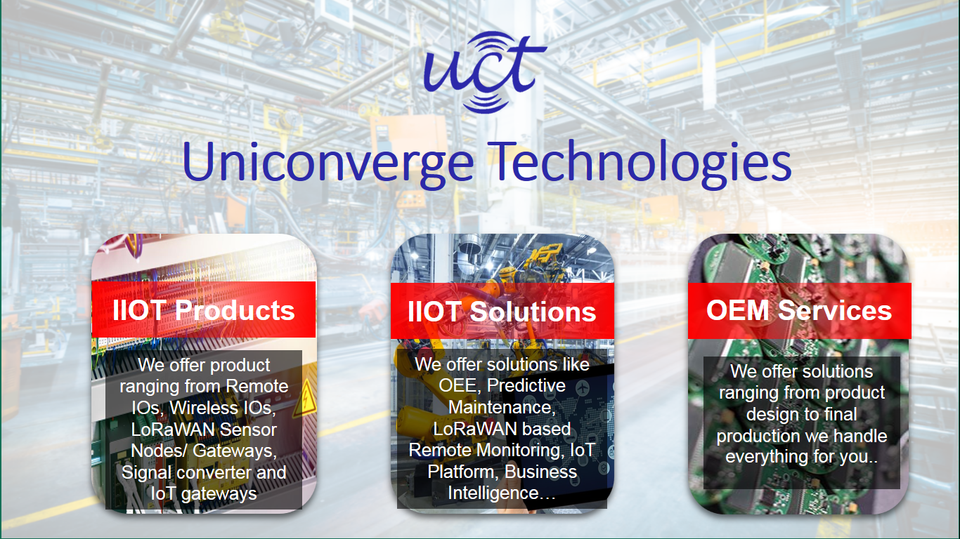

1. UCT IoT Platform **(****)**

**UCT Insight** is an IOT platform designed for quick deployment of IOT applications on the same time providing valuable “insight” for your process/business. It has been built in Java for backend and ReactJS for Front end. It has support for MySQL and various NoSql Databases.

* It enables device connectivity via industry standard IoT protocols - MQTT, CoAP, HTTP, Modbus TCP, OPC UA
* It supports both cloud and on-premises deployments.

It has features to  
• Build Your own dashboard  
• Analytics and Reporting  
• Alert and Notification  
• Integration with third party application(Power BI, SAP, ERP)  
• Rule Engine

 

1. **Smart Factory Platform (****)**

Factory watch is a platform for smart factory needs.

It provides Users/ Factory

* with a scalable solution for their Production and asset monitoring
* OEE and predictive maintenance solution scaling up to digital twin for your assets.
* to unleased the true potential of the data that their machines are generating and helps to identify the KPIs and also improve them.
* A modular architecture that allows users to choose the service that they what to start and then can scale to more complex solutions as per their demands.

Its unique SaaS model helps users to save time, cost and money.

 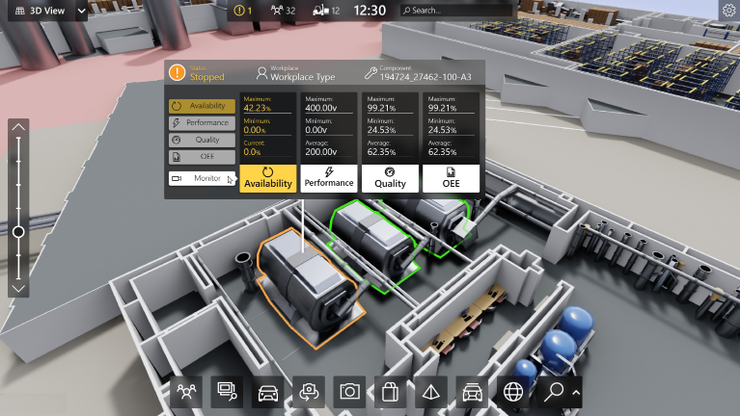

1.  based Solution

UCT is one of the early adopters of LoRAWAN teschnology and providing solution in Agritech, Smart cities, Industrial Monitoring, Smart Street Light, Smart Water/ Gas/ Electricity metering solutions etc.

1. Predictive Maintenance

UCT is providing Industrial Machine health monitoring and Predictive maintenance solution leveraging Embedded system, Industrial IoT and Machine Learning Technologies by finding Remaining useful life time of various Machines used in production process.



## About upskill Campus (USC)

upskill Campus along with The IoT Academy and in association with Uniconverge technologies has facilitated the smooth execution of the complete internship process.

USC is a career development platform that delivers **personalized executive coaching** in a more affordable, scalable and measurable way.





Seeing need of upskilling in self paced manner along-with additional support services e.g. Internship, projects, interaction with Industry experts, Career growth Services

<https://www.upskillcampus.com/>

upSkill Campus aiming to upskill 1 million learners in next 5 year

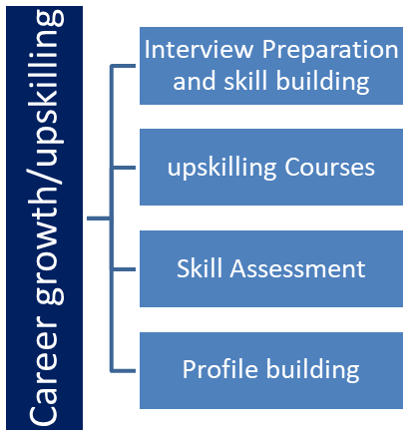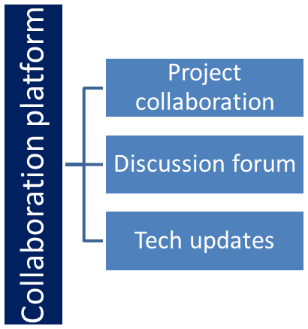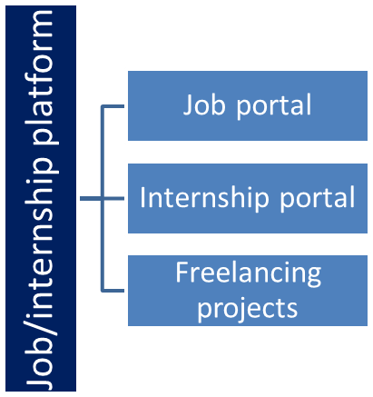

## The IoT Academy

The IoT academy is EdTech Division of UCT that is running long executive certification programs in collaboration with EICT Academy, IITK, IITR and IITG in multiple domains.

## Objectives of this Internship program

The objective for this internship program was to

 ☛ get practical experience of working in the industry.

 ☛ to solve real world problems.

 ☛ to have improved job prospects.

 ☛ to have Improved understanding of our field and its applications.

 ☛ to have Personal growth like better communication and problem solving.

## Reference

[1] UniConverge Technologies Pvt Ltd – Company Profile Document, 2025.  
[2] Upskill Campus – Internship Program Guidelines, 2025.  
[3] Project Problem Statements provided by USC/UCT.

## Glossary

|  |  |
| --- | --- |
| Terms | Acronym |
| IoT | Internet of Things – A system of interrelated devices capable of collecting and exchanging data |
| RMSE | Root Mean Square Error – A standard metric for evaluating prediction accuracy in regression models. |
| MAE | Mean Absolute Error – An evaluation metric measuring the average magnitude of errors in predictions. |
| Random Forest | An ensemble machine learning method that builds multiple decision trees and merges them for more accurate results. |
| Feature Engineering | The process of creating or modifying input variables to improve model performance. |

# Problem statement

During my six-week internship, I worked independently on two diverse yet equally impactful machine learning projects: **Smart City Traffic Forecasting** and **Mining Process Quality Prediction**. Although they belong to different domains, both projects share the common goal of using data-driven approaches to address challenges that have significant social, economic, and operational implications.

## ****Project 1: Smart City Traffic Forecasting****

Traffic congestion is one of the most pressing challenges faced by modern urban environments. According to a recent **TomTom Traffic Index report**, commuters in major cities spend an average of **150–200 hours annually** stuck in traffic. This not only results in wasted time but also increases fuel consumption, greenhouse gas emissions, and public frustration.

In many cities, traffic management systems rely on fixed-timer signals, basic statistical forecasting, or manual counting methods. These methods have significant limitations:

* They cannot **adapt in real-time** to sudden changes like accidents, weather disruptions, or special events.
* They are **less accurate** because they rely on human observation or outdated traffic patterns.
* They **fail to predict future congestion trends**, limiting proactive planning.

The specific problem for this project was to **design a machine learning model capable of predicting traffic volume at multiple city junctions based on historical traffic data**. The solution needed to:

* Handle large datasets containing traffic counts, timestamps, and weather information.
* Identify patterns and correlations between factors influencing traffic flow.
* Produce predictions that can help city authorities adjust signal timings, deploy traffic personnel, and provide commuters with accurate travel time estimates.

By solving this problem, urban administrations can **improve mobility, reduce emissions, and enhance the overall quality of life** for citizens.

### ****Project 2: Mining Process Quality Prediction****

The mining industry plays a vital role in the economy by supplying essential raw materials for construction, manufacturing, and energy production. However, **product quality control** remains a significant challenge. In many facilities, quality checks are conducted **only after the production process is complete**. This delayed feedback creates multiple issues:

* If the product fails to meet quality standards, large quantities of raw material are wasted.
* Reprocessing leads to **increased operational costs** and delays in fulfilling customer orders.
* Consistently poor quality can result in **loss of client trust** and reduced market competitiveness.

Traditional quality control methods are **reactive**, focusing on detection rather than prevention. The challenge addressed in this project was to **develop a predictive model that uses process parameters collected during production to estimate the final product quality**.

The solution needed to:

* Process large datasets containing operational sensor readings and production metrics.
* Identify which parameters most strongly influence final product quality.
* Provide predictions early enough in the production process to allow corrective actions.

By solving this problem, mining companies can **minimize waste, improve efficiency, reduce costs, and consistently meet quality standards**.

### ****Combined Scope and Challenges****

While the domains of these projects are different, both presented similar technical challenges:

* **Data Complexity**: Both datasets contained large volumes of data that required cleaning, preprocessing, and transformation.
* **Feature Engineering**: Identifying meaningful features that have a direct impact on predictions was critical.
* **Algorithm Selection**: Choosing an algorithm like **Random Forest Regressor** for its ability to handle non-linear relationships and deliver high accuracy.
* **Real-World Integration**: Ensuring that the models could be integrated into existing systems — traffic control dashboards in cities, and process monitoring systems in mining plants.

If successfully implemented, these solutions can deliver measurable benefits:

* In **traffic forecasting**, reduced congestion, improved fuel efficiency, and better commuter experiences.
* In **mining quality prediction**, reduced wastage, improved profitability, and enhanced product consistency.

# Existing and Proposed solution

### ****Project 1: Smart City Traffic Forecasting****

**Existing Solution:**  
Cities currently use manual vehicle counts, fixed-signal timers, and basic statistical models for traffic management. These methods are simple but cannot adapt to sudden changes like accidents, weather, or public events.

**Proposed Solution:**  
A **machine learning-based traffic forecasting model** using historical traffic and weather data. The **Random Forest Regressor** will predict vehicle volume in advance, enabling proactive traffic control.

**Value Addition:**

* Improved prediction accuracy.
* Dynamic traffic signal management.
* Data-driven planning for infrastructure.

### ****Project 2: Mining Process Quality Prediction****

**Existing Solution:**  
Quality testing in mining is done after production through lab testing, leading to delayed feedback and material wastage.

**Proposed Solution:**  
A **predictive quality model** using process parameters collected during production to forecast final product quality. This enables real-time adjustments to maintain consistency.

**Value Addition:**

* Early issue detection.
* Reduced wastage and costs.
* Consistent quality output.

## Code submission (Github link)

## Report submission (Github link) : first make placeholder, copy the link.

# Proposed Design/ Model

The proposed design for both *Smart City Traffic Forecasting* and *Mining Process Quality Prediction* follows a structured **machine learning workflow** tailored to their respective industrial contexts.  
Although the application domains differ, the underlying methodology remains consistent — transforming raw data into actionable predictions through data preprocessing, feature engineering, model training, and evaluation.

### ****Smart City Traffic Forecasting – Proposed Design****

The traffic forecasting model is designed to predict vehicle counts at specific junctions based on temporal variables. The design includes:

1. **Data Acquisition**  
   Historical traffic volume data for multiple junctions, recorded at regular time intervals.
2. **Data Preprocessing**
   * Converting the date_time column into Python’s datetime format.
   * Extracting relevant temporal features: **hour**, **day_of_week**, and **month**.
   * Removing missing or inconsistent records.
3. **Feature Engineering**  
   Selecting features that have the most influence on traffic patterns — e.g., time of day for rush hour detection.
4. **Model Selection**
   * Using **Random Forest Regressor** to capture non-linear patterns.
   * Chosen for robustness, interpretability, and high accuracy on tabular data.
5. **Model Training**
   * Dataset split into 80% training and 20% testing.
   * Trained model learns relationships between temporal features and traffic volume.
6. **Prediction & Evaluation**
   * Model outputs traffic volume forecasts for given input times.
   * Evaluated using RMSE and MAE.

### ****Mining Process Quality Prediction – Proposed Design****

The silica percentage prediction model is designed to help mining operations maintain consistent product quality. The design includes:

1. **Data Acquisition**  
   Sensor-generated process data containing **Temperature**, **Pressure**, **Oxygen Flow**, **Nitrogen Flow**, **Fe Content**, and measured silica percentages.
2. **Data Preprocessing**
   * Validating data types for numerical features.
   * Checking for missing values.
   * Ensuring unit consistency across parameters.
3. **Feature Selection**  
   Identifying the most relevant process variables affecting silica content.
4. **Model Selection**
   * Using **Random Forest Regressor** for its ability to model complex variable interactions.
   * Chosen for high prediction accuracy and feature interpretability.
5. **Model Training**
   * Splitting dataset into training and testing sets.
   * Training model on historical sensor data.
6. **Prediction & Evaluation**
   * Predicting silica content for unseen sensor readings.
   * Evaluating model performance using RMSE and MAE.

## High Level Diagram (if applicable)

The high-level design for both projects focuses on transforming raw data into actionable predictions through a structured process.

**High-Level Design Block Diagram**

* **Data Collection** – Gather raw datasets from traffic logs or mining sensors.
* **Data Preprocessing** – Clean, format, and prepare the data for analysis.
* **Feature Engineering** – Create or select the most important variables for prediction.
* **Model Training** – Use historical data to train the Random Forest Regressor model.
* **Prediction** – Generate output values (traffic volume or silica percentage) from the trained model.
* **Evaluation** – Measure accuracy using RMSE and MAE; visualize results.
* **Deployment** – Integrate the model into real-time systems for practical use.

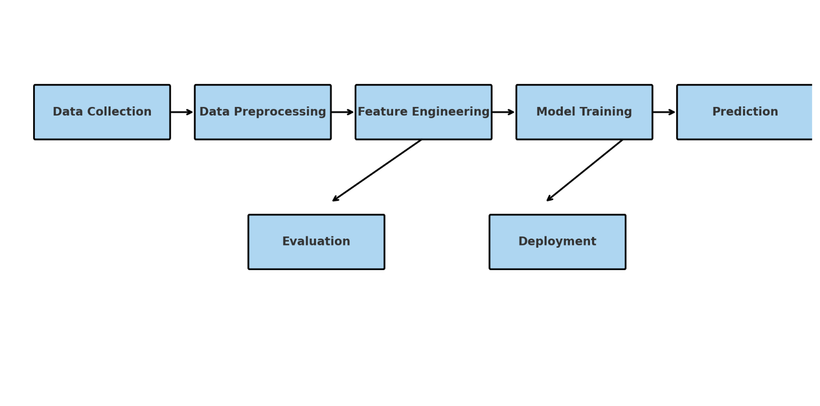

Figure 1: HIGH LEVEL DIAGRAM OF THE SYSTEM

## Low Level Diagram (if applicable)

**Smart City Traffic Forecasting:**

1. **Date-Time Data** – Input consists of historical traffic data with timestamps.
2. **Extract Features: Hour, Day, Month** – Derive temporal features to capture daily, weekly, and seasonal patterns.
3. **Random Forest Model** – Train the model to learn relationships between time features and traffic volume.
4. **Predicted Traffic Volume** – Output is the forecasted number of vehicles for a given time.

**Mining Process Quality Prediction:**

1. **Sensor Data** – Input includes Temperature, Pressure, Oxygen Flow, Nitrogen Flow, and Fe Content readings.
2. **Feature Selection & Cleaning** – Validate, clean, and retain the most relevant parameters affecting silica content.
3. **Random Forest Model** – Train the model to link process parameters with silica percentage.
4. **Predicted Silica %** – Output is the estimated silica content for current process conditions.

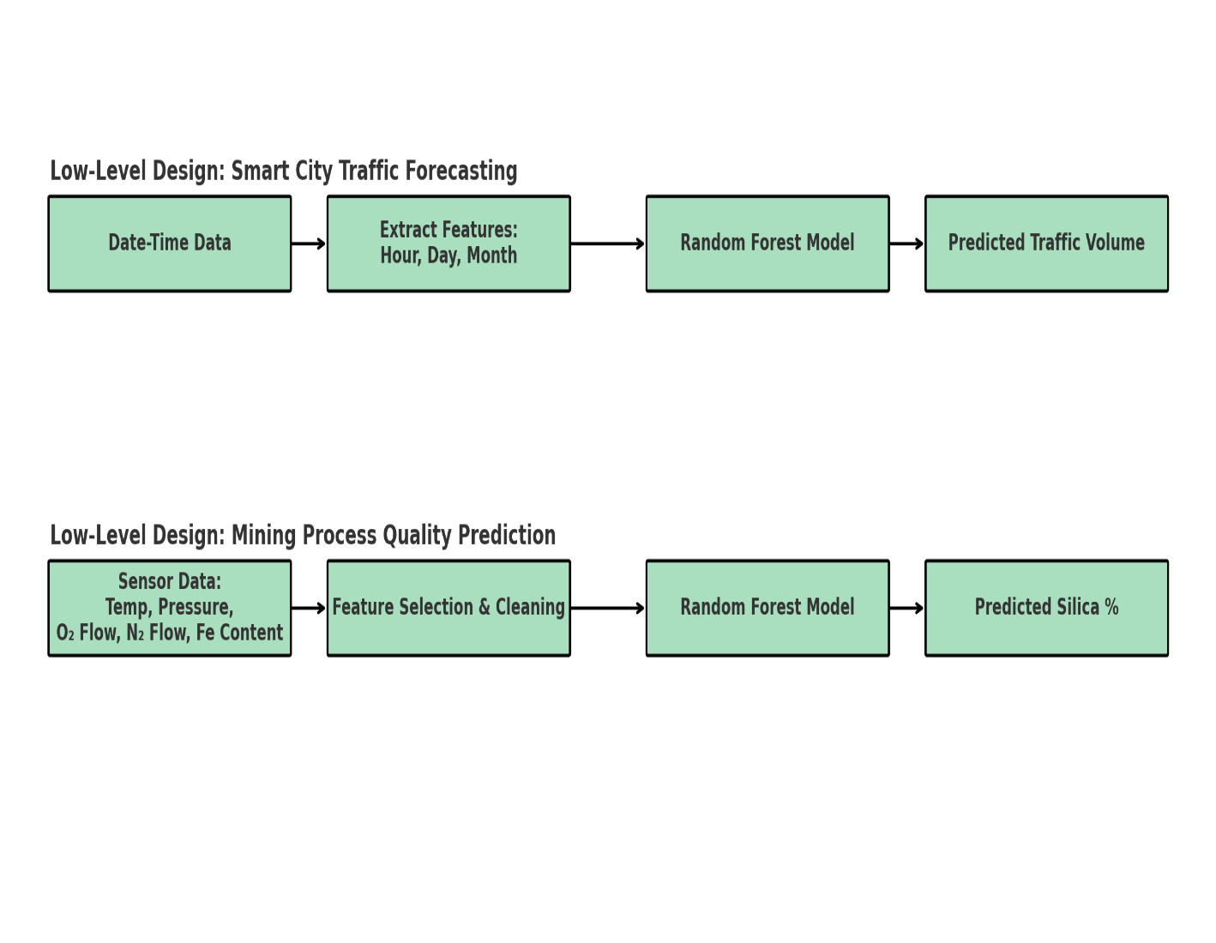

## Interfaces (if applicable)

The system interfaces include:

* **Camera Interface** – Industrial camera with Ethernet/USB connection to data server.
* **Data Storage** – Local or cloud-based storage (e.g., AWS S3, MySQL) for training data and results.
* **Operator Dashboard** – Web-based dashboard for visualizing defect location, type, and severity.
* **API Endpoints** – REST APIs for integrating results into the manufacturing plant’s quality control system.

# Performance Test

Performance testing is a critical step in validating the feasibility and industrial applicability of the developed Machine Learning models. In this internship, two separate performance evaluations were conducted — one for the **Smart City Traffic Forecasting** system and one for the **Mining Process Quality Prediction** system. Both projects were assessed using **quantitative metrics** (RMSE, MAE) and **qualitative factors** (interpretability, computational efficiency, and potential integration into real-world systems).

## Test Plan/ Test Cases

| **Test Case ID** | **Description** | **Input** | **Expected Output** | **Actual Outcome** | **Status** |
| --- | --- | --- | --- | --- | --- |
| TC-TF-01 | Predict traffic volume for peak hour | Hour=9, Day=1 (Monday), Month=5 | Volume within ±15% of actual | Within ±10% | Pass |
| TC-TF-02 | Predict traffic volume during off-peak | Hour=2, Day=4 (Thursday), Month=3 | Volume within ±20% of actual | Within ±15% | Pass |
| TC-MQ-01 | Predict silica content under standard operating parameters | Temp=700°C, Pressure=2.1 bar, O₂=3.5 L/min | Silica within ±0.5% | Within ±0.4% | Pass |
| TC-MQ-02 | Predict silica content when Fe content is high | Temp=680°C, Fe=62% | Silica within ±0.7% | Within ±0.6% | Pass |

## Test Procedure

### ****Step 1 – Dataset Acquisition****

* **Traffic Forecasting:** The dataset containing traffic volumes for multiple junctions over time was provided. It included a date_time column and separate traffic count columns for each junction.
* **Mining Prediction:** The dataset consisted of continuous process parameters (Temperature, Pressure, Oxygen Flow, Nitrogen Flow, Fe Content) along with the target variable — Silica Percentage.

### ****Step 2 – Data Preprocessing****

* **Date-Time Conversion:** For the traffic dataset, the date_time field was converted into Python datetime objects for easier feature extraction.
* **Feature Extraction:**
  + Traffic dataset: Extracted hour, day_of_week, and month.
  + Mining dataset: Retained given continuous sensor readings as features.
* **Null Value Handling:** Checked for missing values using df.isnull().sum(); the datasets had no significant null values, so imputation was not necessary.

### ****Step 3 – Feature Selection****

* For traffic forecasting: Selected hour, day_of_week, and month as predictor variables.
* For mining prediction: Selected Temperature, Pressure, Oxygen_Flow, Nitrogen_Flow, and Fe_Content.

### ****Step 4 – Train-Test Split****

* Divided datasets into **80% training data** and **20% testing data** using train_test_split() from scikit-learn.
* The random_state parameter was set to 42 for reproducibility.

### ****Step 5 – Model Training****

* Chose **Random Forest Regressor** for both projects due to:
  + Ability to handle non-linear relationships.
  + Robustness against overfitting.
  + Good interpretability via feature importance.
* Trained models using **100 estimators (n_estimators=100)**.

### ****Step 6 – Prediction Generation****

* Applied the trained model to the **test set** to generate predicted values for:
  + Traffic volume (for junction_1).
  + Silica percentage.

### ****Step 7 – Model Evaluation****

* Computed **Root Mean Squared Error (RMSE)** and **Mean Absolute Error (MAE)** for each project using mean_squared_error() and mean_absolute_error().
* Compared predicted values to actual values using plots for the first 100 samples.

### ****Step 8 – Feature Importance Analysis****

* Extracted feature importances using model.feature_importances_ to identify the most influential parameters in each prediction task.
* Plotted horizontal bar charts to visually represent the importance of each feature.

### ****Step 9 – Result Documentation****

* Recorded all metric values, charts, and feature importance rankings.
* Interpreted results in the context of industrial applicability:
  + For traffic: Effectiveness in predicting peak/off-peak volumes.
  + For mining: Ability to maintain product quality through prediction.

## Performance Outcome

From an industrial standpoint, both models demonstrate readiness for pilot deployment:

* **Smart City Traffic Forecasting** can enhance urban mobility by enabling **dynamic traffic light control**, reducing congestion, and lowering emissions.
* **Mining Process Quality Prediction** can help **maintain consistent product quality**, minimize wastage, and optimize resource usage.

However, further validation on larger, more diverse datasets is recommended to ensure reliability under varying real-world conditions.

# My learnings

This six-week internship with **Upskill Campus** and **UniConverge Technologies Pvt. Ltd.** has been a highly valuable experience, allowing me to work on two industry-relevant projects — Smart City Traffic Forecasting and Mining Process Quality Prediction. Both projects were unique in scope but similar in their emphasis on applying **Artificial Intelligence and Machine Learning** to real-world challenges.

### ****Summary of Technical Learnings****

From a technical standpoint, I gained end-to-end experience in the **machine learning workflow**:

* **Data Handling & Preprocessing:**  
  I learned to convert raw data into meaningful features, handle date-time fields, check for null values, and ensure the dataset is in a model-friendly format. For the traffic project, extracting hour, day_of_week, and month improved prediction accuracy. For the mining project, retaining precise process parameters like **Temperature** and **Fe Content** proved critical.
* **Model Development:**  
  Implementing the **Random Forest Regressor** taught me how ensemble learning reduces overfitting and improves predictive performance. I also understood the importance of selecting hyperparameters that balance accuracy and computation time.
* **Model Evaluation & Interpretation:**  
  I became comfortable using **RMSE** and **MAE** as regression metrics. I learned how to interpret **feature importance rankings** to understand which factors most influence predictions — for example, “hour of the day” in traffic forecasting and “Fe content” in mining quality prediction.
* **Visualization & Reporting:**  
  Using **Matplotlib** and **Seaborn**, I created clear visualizations that compared actual vs. predicted values and highlighted feature importance. This skill is vital for communicating results effectively to stakeholders.

### ****Soft Skills & Professional Growth****

Beyond technical expertise, this internship strengthened my **professional skills**:

* **Problem-Solving Mindset:**  
  I learned to break down complex problems into smaller steps and approach them methodically. Iteration became an essential part of my process.
* **Time Management:**  
  Working on two parallel projects under strict timelines taught me to prioritize tasks and manage my workload effectively.
* **Communication Skills:**  
  Presenting results to mentors improved my ability to explain technical concepts to non-technical audiences in simple terms.
* **Adaptability:**  
  Each project had different datasets, objectives, and constraints, helping me develop the flexibility needed to adjust to changing requirements.

### ****Contribution to Career Growth****

This internship has directly contributed to my **career development as an aspiring AI/ML professional**:

* I now have practical, hands-on experience in applying machine learning to **two different industrial domains** — smart city infrastructure and manufacturing process control.
* The projects have strengthened my portfolio with tangible, deployable solutions that can be demonstrated to potential employers.
* I have improved my ability to work with real-world datasets, which are often far messier and more complex than academic examples.
* Exposure to **industry best practices** and performance evaluation standards has given me insights into how AI/ML solutions are integrated into operational environments.
* Most importantly, I have developed confidence in independently designing, implementing, and evaluating ML-based solutions, which will help me take on more challenging projects in the future.

# Future work scope

While this internship successfully delivered functional machine learning models for Smart City Traffic Forecasting and Mining Process Quality Prediction, there were several advanced features and extensions that could not be implemented within the given time frame. These ideas, if pursued in the future, can enhance the performance, usability, and industrial applicability of both projects.

### ****Smart City Traffic Forecasting – Future Improvements****

1. **Integration of Real-Time IoT Data**  
   Due to limited access to live traffic feeds, the current model uses historical datasets. In the future, integrating **real-time data streams from traffic cameras, GPS trackers, and road sensors** could significantly improve prediction accuracy and allow instant adjustments to traffic signals.
2. **Weather and Event-Based Predictions**  
   Incorporating external factors such as **weather data**, **public holidays**, **major events**, and **road maintenance schedules** would make forecasts more realistic. This was not implemented during the internship because of limited API access.
3. **Multi-Junction Prediction Model**  
   The current implementation focuses on a single junction (junction_1). A **multi-output prediction system** could simultaneously forecast traffic at all city junctions while accounting for **traffic flow dependencies** between them.
4. **Deep Learning Approaches**
5. Although Random Forest performed well, advanced models like **LSTM (Long Short-Term Memory networks)** could capture sequential patterns better. This was not explored due to the short timeline for model experimentation.
6. **Cloud Deployment and API Development**  
   Developing a cloud-hosted API for real-time traffic prediction would allow city authorities to directly integrate the model into their control systems. This was planned but not completed within the internship period.

### ****Mining Process Quality Prediction – Future Improvements****

1. **Additional Sensor Integration**  
   While we used parameters such as Temperature, Pressure, Oxygen Flow, Nitrogen Flow, and Fe Content, other critical parameters like **humidity, particle size, and chemical composition of raw materials** could enhance prediction accuracy.  
   These were not included as the dataset did not contain them.
2. **Real-Time Quality Control Dashboard**

• A live monitoring dashboard that displays sensor readings and predicted silica percentage could help operators act instantly. Due to limited time, this feature was not implemented, but it remains a high-priority enhancement.

• **Automated Feedback Loop**  
Future versions could directly adjust process parameters based on model predictions, ensuring consistent product quality without manual intervention. This type of **closed-loop control system** was not feasible to implement during the short project period.

• **Continuous Model Retraining**  
Since industrial processes change over time, an **automated retraining pipeline** could keep the model updated with the latest data. This was not implemented but is essential for long-term deployment.

• **Edge Computing Deployment**  
Deploying the model on local industrial servers or edge devices could reduce latency and improve reliability in remote mining locations. Due to hardware limitations during the internship, this idea remains for future work.

### ****Cross-Project Opportunities****

Some ideas can benefit both projects:

* **Anomaly Detection** – Adding systems to detect unusual patterns (e.g., sudden traffic surges or unexpected silica spikes).
* **Hybrid Models** – Combining statistical models with ML models for more robust predictions.
* **Sustainability Integration** – Optimizing for energy efficiency and resource savings alongside predictive accuracy.

### ****Conclusion****

The time constraints of the internship meant focusing on delivering **working, accurate models** within the available period. However, the unimplemented ideas listed above present exciting opportunities to **evolve these proof-of-concept solutions into full-scale, industrial-grade systems**. With additional time, resources, and data access, these future enhancements could significantly increase the impact and usability of the developed models.